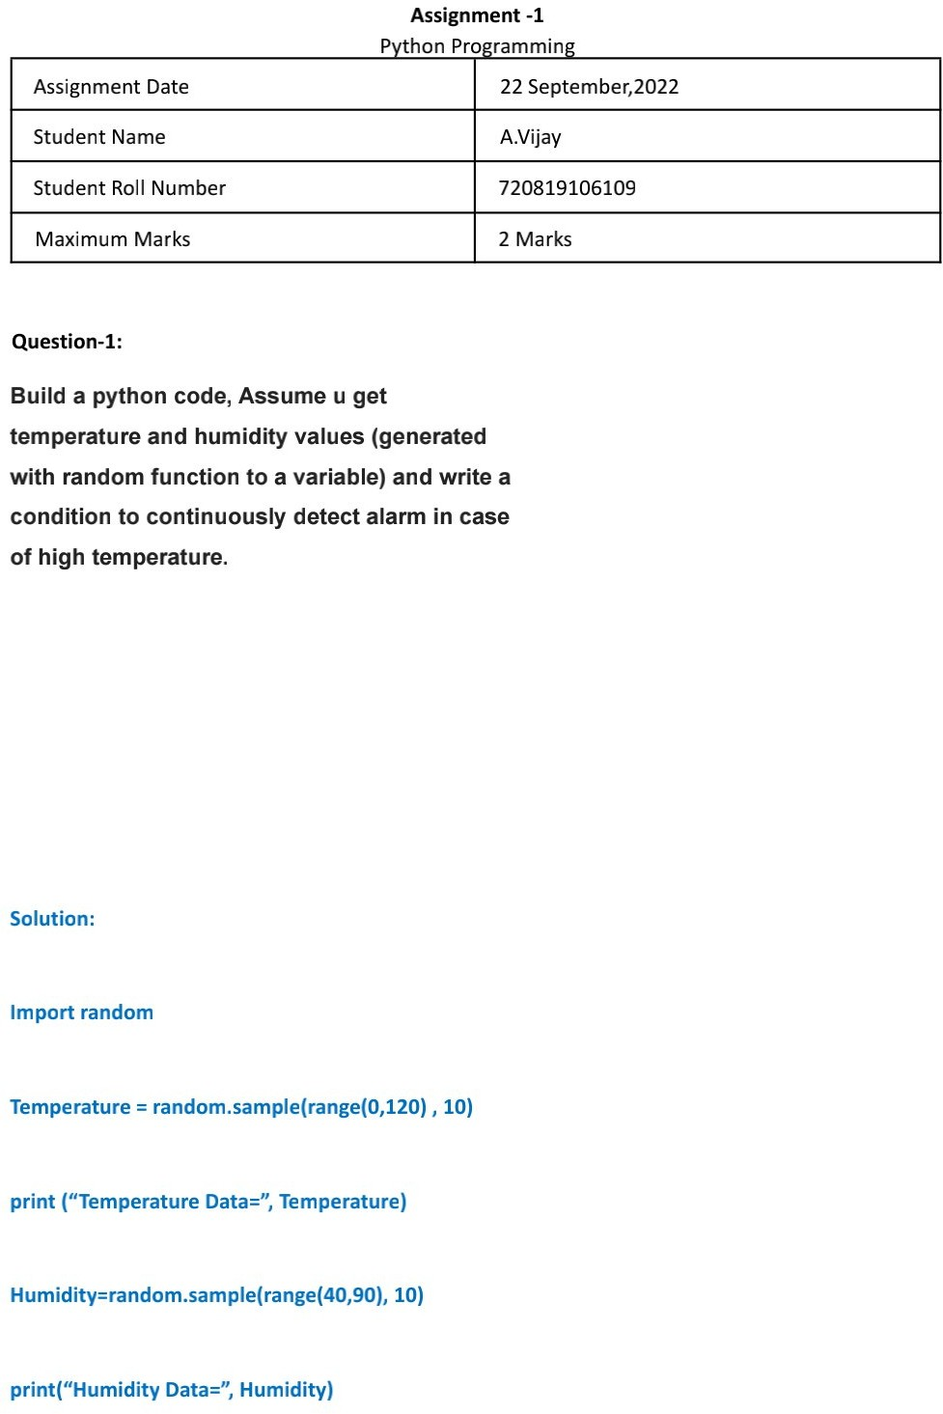

Y Balaji

110719106039

**Assignment - 2**

2 Marks

110719106021

N vijitha

22 September,2022

